For Vendor’s Use:
Project Name | Lease disposal of Grove Park Pavilion, Grove Park, London, NW9 0JP (relates only to former nursery premises and excludes the residential flat)
Contact details | Property Asset Management Team  groveparkpavilion@brent.gov.uk

 | Date: | 05/05/2026
 | Property: | Leasehold disposal of Grove Park Pavilion, Grove Park, London, NW9 0JP
 | Title: | Title Number: tbc  Plan in Appendix 1
 | Conditions of Sale: | See bid conditions in Appendix 2
 | Tenure: | Leasehold - 125 years
 | Owner: | The Mayor and Burgesses of the London Borough of Brent
 | Purchaser:  (Please attach full proof of identification) | Please specify if you are bidding as a private individual or a company  Full Name:  Company/Charity Name & Number if applicable:  Address:  Contact Telephone Number:  Contact Email Address:
 | Planning enquiries: | Please contact the Brent Local Planning Authority. Currently, the property holds a use class E as a restaurant facility.
 | Timescale to exchange and complete: | To exchange contracts within 21 days of receipt of full documentation (an extension may be granted at the Council’s sole discretion), and completion to occur within 14 days upon exchange of contracts.
 | Legal fees: | TBC
 | Value Added Tax: | N/A
 | Your bid:  LEASEHOLD  (All offers must be for a specified sum in Pounds Sterling and to include an amount in pence | Guide Price: £645,000 (subject to overage if applicable)  Please bid an odd number of pounds and pence, this will reduce the likelihood of the same bid being made.  Unconditional offer in figures: £  Amount in words:
 | Payment Terms: | - 10 % nonrefundable deposit to be paid on Exchange of the Contract for sale.  - The balance of the premium to be paid on completion.
 | Financial Standing & Funding details:  60% assessment  weighting | - A pre-requisite for a bid to be considered is good financial standing and evidence of ability to fund this purchase.  - Amount of borrowing: £  - Amount of bid: £  - Amount of cash: £  Loan to value percentage  (‘a’ divided by ‘b’ multiplied by 100):  Please attach proof of deposit and proof of funds and/or mortgage offer.
 | Social Value:  40% assessment weighting | Please specify any social value you aim to deliver:
 | Owner’s Solicitor:  PLEASE DO NOT CONTACT PRIOR TO BIDDING TERMS BEING AGREED | Company Name: Legal Services LB Brent  Company Address: Civic Centre, Engineers Way, HA9 0FJ  Contact Name: TBC  Telephone: TBC  Email Address: TBC
 | Purchaser’s Solicitor: | Company Name:  Company Address:  Contact Name:  Contact Position:  Contact Telephone Number:  Contact Email Address:
 | Exchange Date: | TBC
 | Completion Date: | TBC
 | SIGNED: | For and on behalf of the Purchaser:  Name:  Title:  Date:
 | Appendices: | - Appendix 1: Red line plan of Grove Park Pavilion  - Appendix 2: Bid conditions  - Appendix 3: Connection or Interest Questionnaire – please complete.

NOTE: These Terms are for information purposes only and may be subject to change prior to the issue of the Contract for Sale.

Essential Notes to all Bidding Parties

- Offers will only be considered if they are set out in this form, as set out above, and returned to the email address as directed above and before 20th May 2026 at 5pm.
- This form together with the Council’s Equalities Form and Connection or Interest Form should be completed in full and failure to do so could prejudice your offer.
- All offers received by the closing date and time will be opened together.
- Your offer detailed above, in ‘purchase price’ section of the Form, should be the minimum guaranteed price and any overage should be stated separately.
- The Vendors may request further information in respect of any offer including financial references and/or company accounts and offers may be rejected if these do not adequately demonstrate ability to proceed with the purchase and the proposed works, in the opinion of the Vendors.
- Disposal is subject to Vendors’ approvals processes.
- Nothing in this document is to constitute, or be deemed to constitute, a contract.
- The Council is not obliged to accept the highest offer or any offer.

Returning Application instructions

Please submit this document and add all other required documentation in 1 Zip Folder by using the link below:

Project: Bids Submission | London Borough of Brent

Appendix 1: Red line plan of Grove Park Pavilion

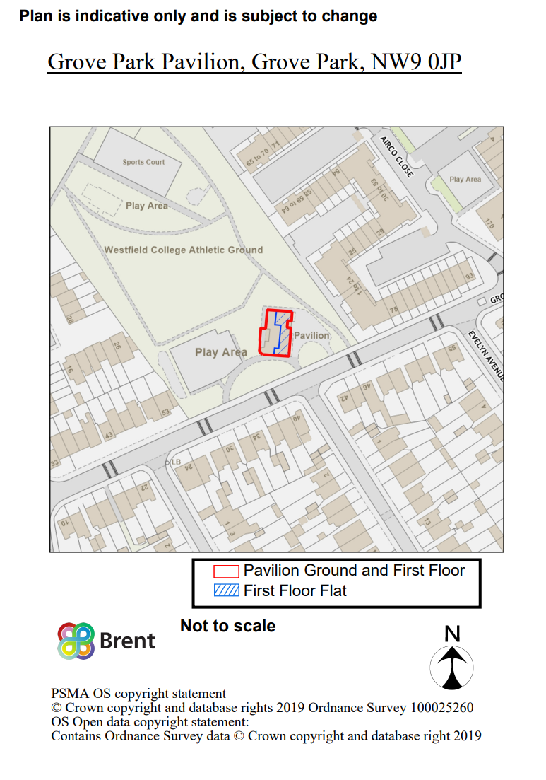

Appendix 2: Bid conditions

- All bids are to be non–binding and must be submitted via the submission portal by 5pm on 20th May 2026 addressed to the groveparkpavilion@brent.gov.uk . Bids are to be made in pound sterling and given in figures and words, to be a fixed amount and not to be expressed in a conditional form relating to other bids received.
- Interested parties must provide a minimum of the following information:-
  - Attached form to be completed in full.
  - Two recent letters showing proof of address e.g.: a bank/credit card statement, utilities or council tax bill
  - Photograph of individual(s)' passport (certified copy may be required on request)
  - An offer in principle from Mortgage Company/Confirmation from mortgage broker of approved loan if applicable.
  - Proof of deposit and proof of funds.
  - Confirmation of solicitor’s instructions and full proof of identification.
- The property description given is based on the best available information, but the Council makes no guaranty, warranty, or representation expressed or implied as to the quantity, kind, character, size, quality, weight or description of the property, or its fitness for any use or purpose and no bid shall be considered for allowance or adjustment based on applicants failure to satisfy themselves of the condition of the property.
- The applicant is responsible for investigating the prospect of obtaining all requisite consents, including planning permission.
- The contract for sale will be non-assignable whether prior to exchange or completion.
- The successful applicant will be required to exchange contracts unconditionally within 21 days of receipt of full draft documentation (an extension may be granted at the Council’s sole discretion), paying a 10% deposit upon exchange of contracts. If the Council is not satisfied with the progress of the sale the Council reserves the right to withdraw the property from sale or offer the sale of the property to another bidder.
- Completion of the purchase will occur within 14 days after exchange of contracts.
- The Council reserves the right to accept or reject any and/or all bids in the best interest of the Council.
- The Council also reserves the right to withdraw the property from sale at any time for any reason.
- The above information does not constitute part of an offer or contract.
- The disposal of the Property is subject to the Council’s internal governance arrangements, including (without limitation) approval under the Council’s Key Decision process. The Council reserves the right not to proceed with the sale unless and until all requisite approvals have been obtained.
- Each prospective purchaser shall be deemed to have carried out and shall be wholly responsible for its own independent due diligence, investigations and enquiries in relation to the Property. The Council gives no warranty or representations in respect of the property and accepts no liability whatsoever arising from reliance on any information provided.
- Bidders are advised that the Council is under a statutory duty to dispose of land in accordance with the Local Government Act 1972 and associated legislation, including the obligation to achieve best consideration reasonably obtainable (unless statutory consent provides otherwise). Accordingly, the Council is not bound to accept the highest or any bid received.

Appendix 3: Connection or Interest Questionnaire

Background

Officers and Members have a duty to act in the best interest of the Council. They must avoid situations where their personal interest conflict or duties conflict with their duty to the Council unless they have been authorised to do so in accordance with the Council’s procedures. The duty also extends to conflicts that arise because of persons connected with them. Conflicts of interest can occur in many ways. A conflict of interest can occur where an Officer/ Member or connected person stands to benefit personally from the Council. Conflicts of interest must therefore be appropriately identified and this questionnaire should help.

Questionnaire

Please answer the following questions:

*Please circle as appropriate.

- Are you a Councillor or Brent Employee?

*Yes No N/A

- Do you have a spouse, co-habiting partner, child, parent or business associate who is employed by Brent Council at a senior level or who is a Councillor?

*Yes No N/A

- Have any of your directors/partners/company secretary ever worked for or are currently employed by Brent Council?

*Yes No N/A

- Have any of your directors/partners/company secretary ever served as or are currently a Councillor at Brent Council?

*Yes No N/A

- Does any of your directors/partners/company secretary have a spouse, co-habiting partner, child, parent or business associate who is employed by Brent Council at a senior level or who is a Councillor?

*Yes No N/A

- Are you award of any existing customer of your organisation whose interests may overlap with those of the Council, such that your organisation could have a conflict of interest in advising that customer as well as Brent Council?

*Yes No N/A

- Is there any basis on which there maybe or perceived to be a conflict or interest, i.e. a connection that may provide you with a potential advantage over other bidders or put you in a position where there maybe a conflict of interest between you/ your organisation and Brent?

*Yes No N/A
If the answer to any of the questions 1-5 is yes please provide more details on a separate page, including details of the Brent connection, the person’s name and role.

Next steps

If a conflict is identified, you must not use your position in way to gain an advantage. Officers will treat conflicted applicants in the same manner as any other bidder so that the Council can demonstrate that it has not shown any favouritism to you and any declaration will be appropriately reported. The connection will be reported to the appropriate officer’s line manager and approach agreed. All connections will be reported in decision making reports and recommendations.

Corporate policy emphasises the responsibility of Officers and Members to declare connections of interest.

