

**Area SEND inspection**

**Parent and carer views (Easy Read)**

**Please complete the survey online if you can.**

**You can find the online survey for your local area using this link** [**https://www.gov.uk/government/publications/local-area-send-inspections-information-for-families**](https://www.gov.uk/government/publications/local-area-send-inspections-information-for-families)**. Please scroll down to the heading ‘Areas we will inspect’ to find the survey for your local area.**



For parents and carers of children or young people aged up to 25 with special education needs and/or disabilities (SEND).

Please return your answers to [data.areasend@ofsted.gov.uk](mailto:data.areasend@ofsted.gov.uk) by **3pm on 20 January 2025.**

Please add **Brent Local Area Partnership** to the title of your email.

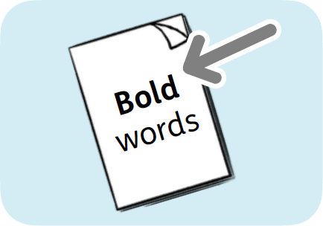In this Easy Read document, hard words are in **bold**. We explain what these words mean in the sentence after we have used them.

**Introduction**

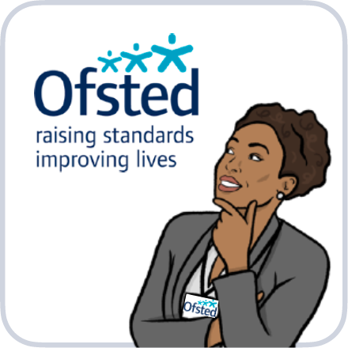  
The Office for Standards in Education, Children’s Services and Skills (Ofsted) checks the quality of education services in England, like schools and nurseries. We also look at children’s social care.

The Care Quality Commission (CQC) checks the quality of health and social care services in England, like hospitals and care homes.

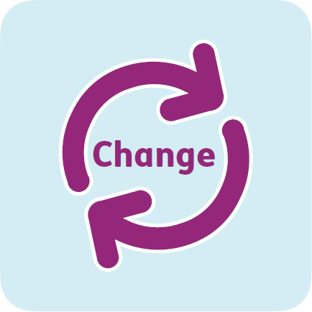  
Together we are looking at what services are doing to make a difference and improve the lives of children and young people with SEND.

  
We want to make sure local services are meeting the needs of children and young people with SEND.

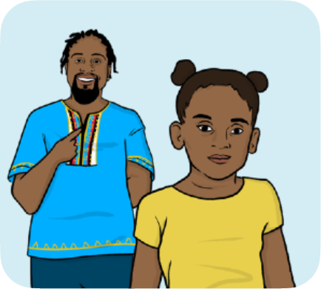

Please only answer these questions if you are the parent or carer of a child or young person aged 25 or under with SEND.

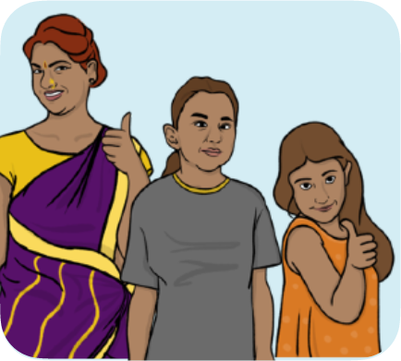  
If you have more than 1 child with SEND, you can do a survey for each child.

If you have difficulties using this survey, please email:  
[lasend.support@ofsted.gov.uk](mailto:lasend.support@ofsted.gov.uk)  
  
You can ask someone to email for you.

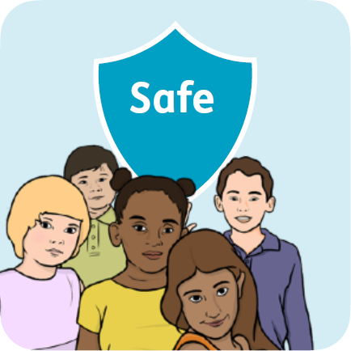**Safeguarding**

**Safeguarding**is keeping people safe from harm and abuse.

If you think a child or young person is being harmed or abused, contact your local council.

We do not ask for your name, but we may try to find out who you are if you tell us something that makes us worried about you or another person. We will tell the local council and health services if you tell us something that makes us worried.

  
You can find out more about how to do this here:  
[www.gov.uk/report-child-abuse-to-local-council](https://www.gov.uk/report-child-abuse-to-local-council)



For young adults over the age of 18, call your local council and ask to speak to the adult safeguarding team. You can also look on the local council website.

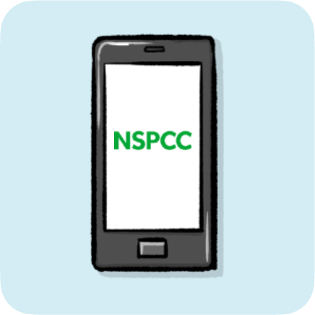You can also contact the NSPCC on  
0808 800 5000.

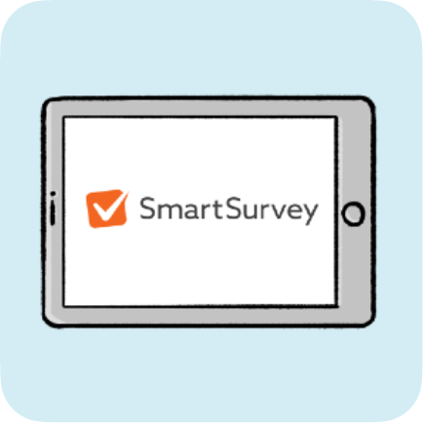**Your information**

We will treat the information you give us in confidence.

This survey is run by SmartSurvey. You can find out what they will do with your information here:  
[www.smartsurvey.co.uk/privacy-policy](http://www.smartsurvey.co.uk/privacy-policy)

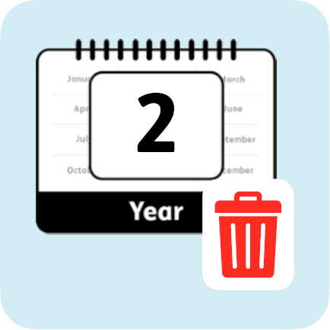SmartSurvey passes your information to Ofsted.  
  
SmartSurvey and Ofsted will delete the information after 3 years.

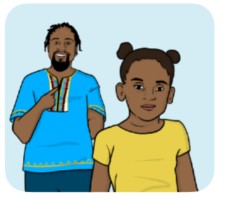

**Question 1:** Does your child have SEND?

If you answer ‘no’ to this question, the survey will close. (Please choose one)

|  |  |  |
| --- | --- | --- |
|  | Yes | Go to question 2 |
|  | No | Stop the survey |
|  | I am not sure, but I think they probably do | Go to question 2 |

**Question 2:** Please click which of these your child has:

See the next page for more answer choices.

|  |  |
| --- | --- |
|  | Autism spectrum disorder |
|  | An **impairment** to do with their hearing  An **impairment** is when part of the body doesn’t work as it should |
|  | An impairment to do with more than 1 sense, like seeing and hearing |
|  | A moderate learning difficulty- this means they sometimes find it difficult to understand, learn and remember information |
|  | A physical disability- this is a disability to do with their body |
|  | Profound and multiple learning difficulties- this means their disability has a big effect on how they live. They might have difficulties seeing, hearing, speaking and moving |
|  | A severe learning difficulty- this means they find it difficult to understand, learn and remember information |
|  | Difficulties with their mental health, emotions and/or behaviour |
|  | A specific learning difficulty- this means they find a part of learning difficult |
|  | Speech, language and communication needs- this means they need support to talk to or understand others |
|  | An impairment to do with their sight |
|  | Other |



**Question 3:** If you would like to, please tell us more about your child’s special educational needs and/or disabilities.

|  |
| --- |
|  |

 **Question 4:** How old is your child?

(Please choose one)

|  |  |  |
| --- | --- | --- |
|  | 0 to 4 years old |  |
|  | 5 to 10 years old |  |
|  | 11 to 15 years old |  |
|  | 16 to 19 years old |  |
|  | 20 to 25 years old |  |

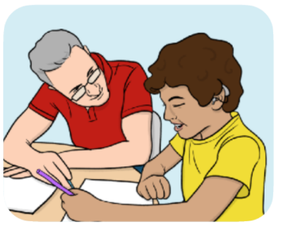**Question 5:** Is your child currently in education? (This could be pre-school, school, college or training) (Please choose one)

|  |  |  |
| --- | --- | --- |
|  | Yes | Go to question 6 |
|  | No, they do not have a place at a school, college or training provider | Go to question 8 |
|  | No, they have a place at school, college or training provider, but they do not go | Go to question 8 |

**Question 6:** Where does your child go to learn?

|  |  |
| --- | --- |
|  | A pre-school, nursery, or childminder |
|  | A mainstream school- this is a school that most children go to |
|  | A private school - this is a school you have to pay to go to |
|  | A special school or college for children or young people with SEND |
|  | Alternative provision – this is for children and young people who can’t attend mainstream school, for example, because they have been excluded or have needs which can’t be met |
|  | University |
|  | At home |
|  | They are training for a job |
|  | Other – please say. Please do not write the name of the place or where it is |
|  |  |

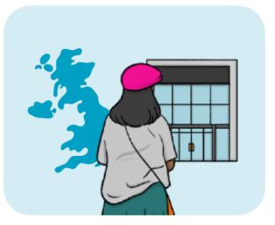**Question 7:** Does your child go to a school, college or training in your local area?

(Please choose one)

|  |  |  |
| --- | --- | --- |
|  | Yes | Go to question 9 |
|  | No | Go to question 9 |
|  | Not sure | Go to question 9 |

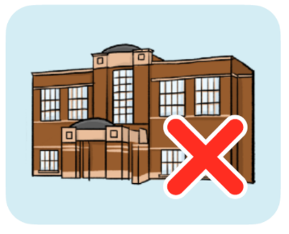**Question 8:** If your child is not in school, college or training, please tell us more about why that is.

|  |
| --- |
|  |

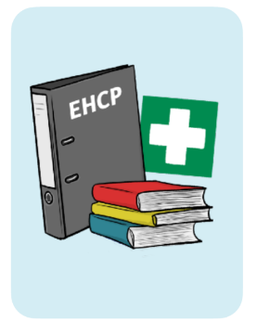

**Question 9:** **Does your child have an** Education, Health and Care **(EHC) plan?**

An **EHC plan** explains what needs your child has and what support they should get. (Please choose one)

|  |  |
| --- | --- |
|  | Yes |
|  | No – we are trying to get one |
|  | No – we tried to get one but couldn’t |
|  | No - we have not asked for one |
|  | Not sure |

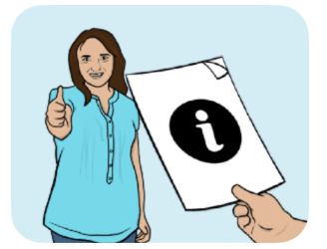

**Question 10:** Do you get clear information and advice to help you make decisions about your child’s future?

(Please choose one)

|  |  |
| --- | --- |
|  | Yes, always |
|  | Yes, most of the time |
|  | Sometimes |
|  | No |
|  | Not sure |



**Question 11:** Do you know about the different services you can access to help support your child?

This could be from schools, health or care services.

(Please choose one)

|  |  |
| --- | --- |
|  | Yes, I know which services I can get |
|  | I know about some services |
|  | No, I do not know which services I can get |
|  | Not sure |

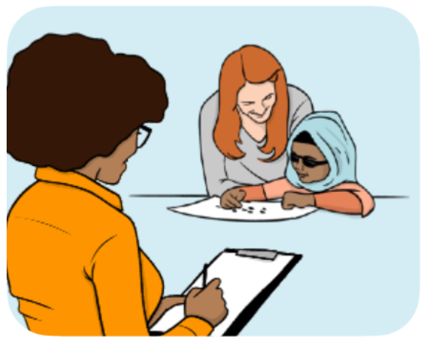**Question 12:** Are your child's needs spotted and understood at the right time?

(Please choose one)

|  |  |
| --- | --- |
|  | Yes, always |
|  | Yes, most of the time |
|  | Sometimes |
|  | No |
|  | Not sure |

**Question 13:** If you would like to, please tell us more about whether your child’s needs were spotted and understood at the right time.

|  |
| --- |
|  |

**Learning and training**

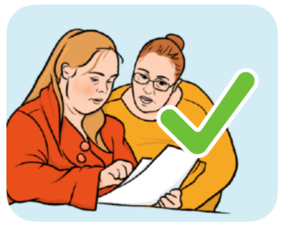**Question 14:** Does your child get the right help and support for their learning and/or training?(Please choose one)

|  |  |  |
| --- | --- | --- |
|  | Yes, always | Go to question 15 |
|  | Yes, most of the time | Go to question 15 |
|  | Sometimes | Go to question 15 |
|  | No | Go to question 15 |
|  | They do not need support in their learning and/or training | Go to question 17 |
|  | Not sure | Go to question 15 |

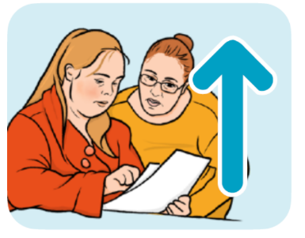

**Question 15:** What support in their learning and/or training could be better?

|  |
| --- |
|  |

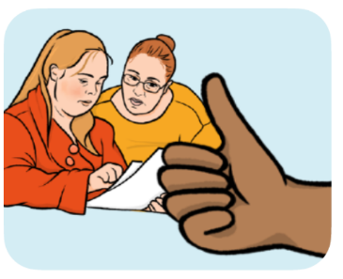**Question 16:** What support in their learning and/or training is working well?

|  |
| --- |
|  |

**Healthcare services**



Healthcare services can include:

* doctors

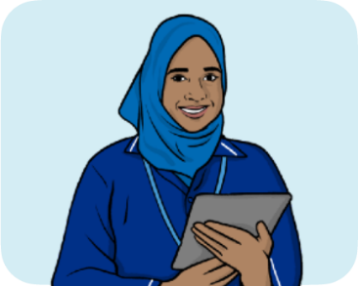

* nurses

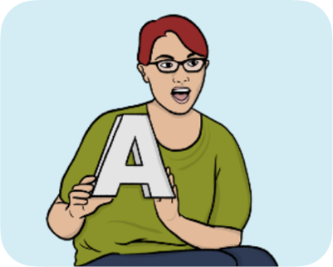

* help with speaking from health staff

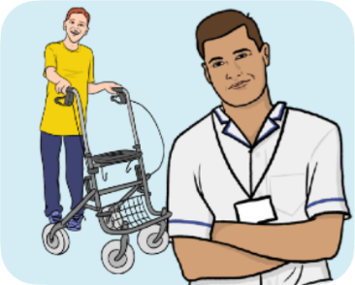

* help with moving around from health staff

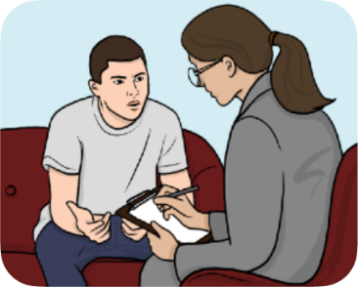

* help with mental health, emotions and/or behaviour

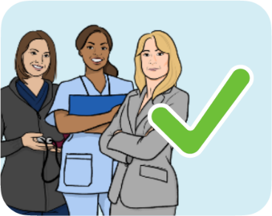**Question 17:** Does your child get the right help and support from healthcare services?

(Please choose one)

|  |  |  |
| --- | --- | --- |
|  | Yes - always | Go to question 18 |
|  | Yes - most of the time | Go to question 18 |
|  | Sometimes | Go to question 18 |
|  | No | Go to question 18 |
|  | They do not need support from health services | Go to question 20 |
|  | Not sure | Go to question 18 |
|  |  |  |

**Question 18:** What support from health services could be better?

|  |
| --- |
|  |

**Question 19:** What support from health services is working well?

|  |
| --- |
|  |

**Social care services**

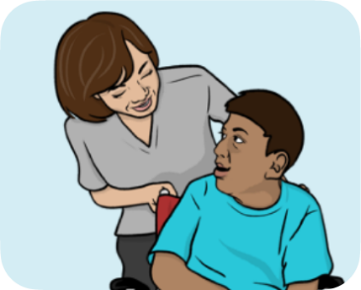 **Social care** is the help people need with everyday things such as personal care or support for the family.

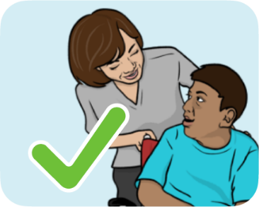

**Question 20:** Does your child get the right help and support from social care services?

(Please choose one)

|  |  |  |
| --- | --- | --- |
|  | Yes - always | Go to question 21 |
|  | Yes - most of the time | Go to question 21 |
|  | Sometimes | Go to question 21 |
|  | No | Go to question 21 |
|  | They do not need support from social care services | Go to question 23 |
|  | Not sure | Go to question 21 |

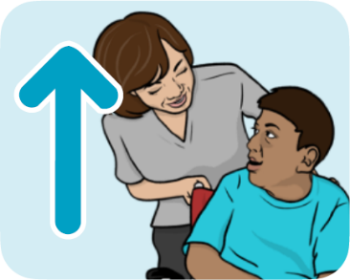**Question 21:** Whatsupport from social care services could be better?

|  |
| --- |
|  |

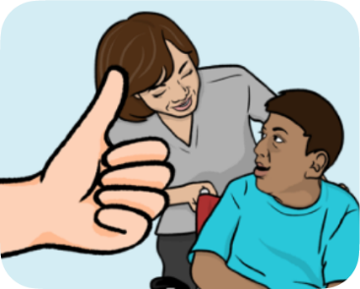**Question 22:** What support from social care services is working well?

|  |
| --- |
|  |

**Spending time with others**

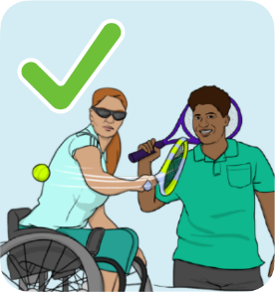**Question 23:** Does your child get the right help or support to:

* join in with clubs or activities?
* go on holiday?
* make friends?(Please choose one)

|  |  |  |
| --- | --- | --- |
|  | Yes - always | Go to question 24 |
|  | Yes - most of the time | Go to question 24 |
|  | Sometimes | Go to question 24 |
|  | No | Go to question 24 |
|  | They do not need support in their social life | Go to question 26 |
|  | Not sure | Go to question 24 |

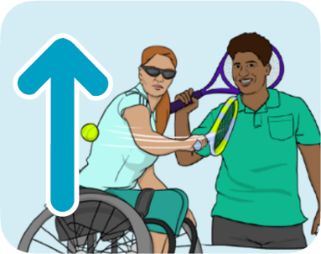**Question 24:** What support to spend time with others could be better?

|  |
| --- |
|  |

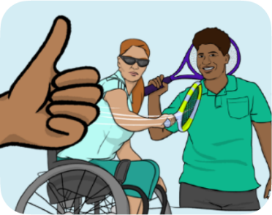**Question 25:** What support to spend time with others is working well?

|  |
| --- |
|  |

**Getting ready for the future**

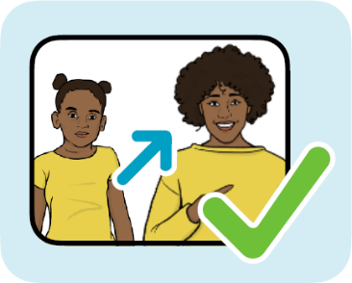**Question 26:** Does your get the right help and support to get ready for the future?

****This could be to go to college, get a job, or be able to do more for themselves.

(Please choose one)

|  |  |  |
| --- | --- | --- |
|  | Yes, always | Go to question 26 |
|  | Yes, most of the time | Go to question 26 |
|  | Sometimes | Go to question 26 |
|  | No | Go to question 26 |
|  | They do not need support | Go to question 28 |
|  | They are too young | Go to question 28 |
|  | Not sure | Go to question 26 |

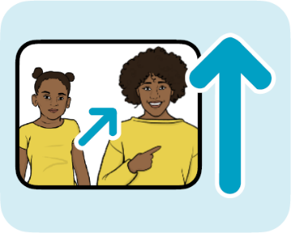**Question 27:** What support to get them ready for the future could be better?

|  |
| --- |
|  |

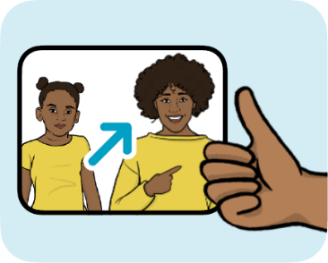**Question 28:** What support to get them ready for the future is working well?

|  |
| --- |
|  |

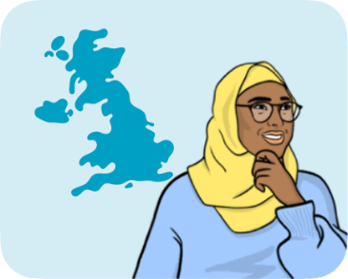**Where do you live?**

We would like to know where you live, to see if people in different places think differently.

  
You do not have to tell us if you do not want to.

**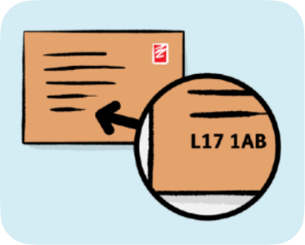  
Question 29**: Please write your postcode if you would like to.

|  |
| --- |
|  |

**For more information**

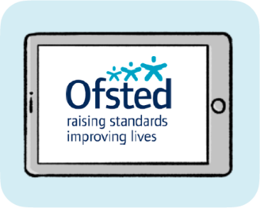  
You can find out more about what we do to check on local services here:  
<https://www.gov.uk/government/publications/area-send-framework-and-handbook>