Date Received:

Received by:
FACILITY HIRE FORM

Brentfield Harrow Road Stonebridge LONDON NW10 0RG Telephone 020 8937 3730

ALL SECTIONS OF THE FORM MUST BE COMPLETED

Name of Hirer: ___________________________ (DOB--/--/--)

Organisation (if applicable): ________________________________________

Address: ________________________________________

________________________________________

Post Code ________________________________________

Invoicing Name and Address: ________________________________________
(if different to above)

Telephone: Work: ________________________________________

Home (if applic): ________________________________________

Mobile: ________________________________________

Fax: ________________________________________

E-mail: ________________________________________

Purchase Order Number: (if applic) _____________________________

Date(s) of Proposed Hire: ________________________________________

Exclusion dates (if applic): ________________________________________

_______________________________________

Room(s) to be hired: (Please Tick) Please note maximum numbers are dependent on layout style
Conference Room (max 70) □ Syndicate Room (max 16) □
Tropics Suite (max 80) □ Community Suite (max 45) □
Board Room (max 12) □ Dance Studio □
Sports Hall □ Function Hall □ Kitchen □ Servery □ Upper Foyer □

Maximum numbers attending: ___________

Start Time: _______ End Time: _______ Proposed Arrival Time: ____________

State the purpose of the Hire: _________________________________________

MEETING/FUNCTIONS ROOMS LAYOUT REQUIREMENTS
(Please tick and enter attendance figures)

Horseshoe –Tables & Chairs ________ Horseshoe-chairs only _______

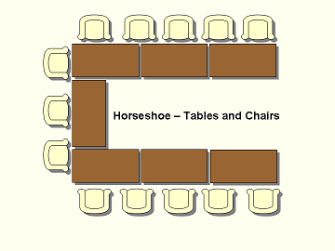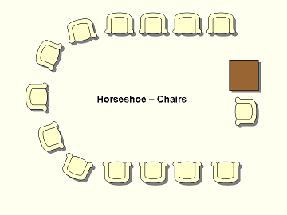

Boardroom-Tables & Chairs ______ Cabaret/Group – Tables & chairs
________
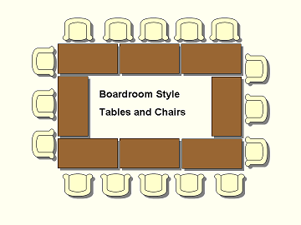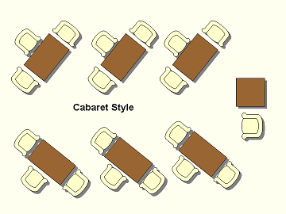

Theatre – Chairs only ________
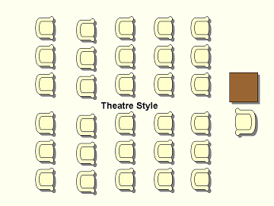

FUNCTION HALL SPORTS HALL
Restaurant style (max 150) _____ Restaurant style (max 400) ______

Theatre style (max 300) _____ Theatre style (max 500) ______

Any other layout (please state) ____________________________________

Do you require a top table? YES NO

If ‘YES’, please indicate how many chairs are required: __________

CATERING REQUIREMENTS
Tea / coffee with biscuit £1.50 per cup □

Please indicate time(s) for refreshments to be available?

________________________________________________________

MEETING ROOM EQUIPMENT REQUIREMENTS (Please Tick)
Free WIFI

None Flip Chart & Easel

Computer Access * * Overhead Projector *

White Board Screen *

CD Player

Available in Conference & Syndicate Rooms only *

Provision of equipment will be subject to a refundable security deposit

Additional Flip Charts:
A fee of £4.00 + VAT will be charged for all charts provided in addition to the first one
per room. If any further flip charts are necessary for your meeting, then please state
the additional number required:
____________________

Will you be bringing any equipment of your own? YES NO

If ‘YES’, please state the type of equipment:
____________________________________________________________________

NOTE TO ALL HIRERS

ALL Electrical Equipment must bear a valid Electrical Equipment Test label prior to its use at the Centre . All equipment will be used via wall mounted RCD sockets to ensure that there is no overload within the Centre. If any defect develops as the result of faulty equipment then the use of the equipment will have to cease immediately. Any equipment brought on site must be set up by a competent person. The Council will take no responsibility for equipment not set up correctly.

____________________________________________________________________________________

PHOTOCOPYING

The Centre is able to provide both photocopying on the day of hire, which should be requested at Sports Reception on the ground floor. Prices are available on request and payment is to be made on the day.

EMERGENCY EVACUATION (Please Delete)

In the occurrence of an emergency are you aware of any person(s) attending your event who will require assistance in the necessity to evacuate the building? YES / NO

If ’YES’, please state the number of persons who will require assistance: _________

CATERING REQUIREMENTS

If you require catering with your facility hire it is the responsibility of the hirer to arrange the services of a suitably qualified caterer.

The hirer is responsible for clearing away any food and drink waste.

Please note that only light refreshments (eg. Tea, coffee, biscuits etc) are allowed in the Conference and Syndicate rooms. Lunches are to be served in the upper foyer area, in the area immediately outside the rooms, or as directed by Centre management. Catering arrangements (for all rooms) must be approved by the Centre management in advance.
If selling food does your caterer have an appropriate
Food Hygiene qualification YES NO

If bringing own drinks, will alcohol be sold? YES NO

If selling alcohol, do you have a Temporary Event Notice YES NO

If ‘No’ a Temporary Event Notice will be required via Brent Council’s Health, Safety and Licensing Department (allow at least 14 working days to obtain this licence)
A copy of the Temporary Licence must be made available to the centre at least 7 days before the event. Without a Temporary Event Notice alcohol CANOT be sold.

DECLARATION

I declare that I am eighteen years or over and that the information given is correct. I have read and agree to abide by Brent Council’s Terms & Conditions of Hire. I understand that by completing this form that the proposed booking is yet to be confirmed by the centre, and therefore do not hold the Centre responsible for any costs associated with this proposed event should the event not be able to be held.

Signature of Applicant: ________________________ Date: __________________

Name of person who will be responsible for the event on the day __________________________

Contact number of person who will be responsible on the day _______________________________

(Please note the above named contact must be present at the pre-event meeting)

Your personal information will be electronically stored, and may be used to send you information about other developments / activities and promotions organised by Brent Council. Please tick this box if you DO NOT wish to receive any such information: □

Please help us to ensure that all activities meet the needs of all the ethnic groups within our diverse borough, by telling us about your booking participants. Any information you provide is totally confidential and although it is not compulsory, all information gathered will help us to provide a better service to all sections of the community.

Please tick the ethnic group you most identify yourself/your participants with:
Asian or Asian British | Black or Black British | Other ethnic groups
◻ Indian  ◻ Pakistani  ◻ Chinese  ◻ Any other Asian background | ◻ African  ◻ Caribbean  ◻ Somali  ◻ Other Black background | ◻ Afghan  ◻ Eastern European  ◻ Turkish  ◻ Other ethnic group
White | Mixed Race / Dual Heritage
◻ British/English/Welsh/Scottish/Northern Irish ◻ Irish ◻ Gypsy Roma  ◻ Traveller of Irish Heritage  ◻ White other | ◻ White/Black Caribbean  ◻ White/Black African  ◻ White/Asian  ◻ Any other mixed background | ◻ Prefer not to say

How did you hear about us?
◻ Member Referral ◻ Word of mouth ◻ Corporate
◻ Advert (WHERE, PLEASE STATE) …………………………………...
◻ Promotion (PLEASE STATE) …………………………………….
◻ Other (PLEASE STATE) …………………..….……………..........

What is your sexuality?
◻ Heterosexual/Straight ◻ Bisexual ◻ Gay Man ◻ Gay Woman/Lesbian
◻ Prefer not to say

What is your religion?
◻ Agnostic ◻ Buddhist ◻ Christian ◻ Hindu ◻ Humanist ◻ Jewish ◻ Muslim ◻Sikh ◻ No Religious belief ◻ Prefer not to say
◻ Other (PLEASE STATE) ………………………………………...

Do you consider yourself to have a disability? | .◻ Yes .◻ No .◻ Prefer not to say
If you have a disability, please indicate which reflects your disability:
◻ Hearing (deaf, partially deaf or hard of hearing)
◻ Learning Disability (dyslexia, autism)
◻ Long Term Illness (cancer, HIV, multiple sclerosis, diabetes) . .
◻ Mental Health (depression, schizophrenia)
◻ Physical Impairment (using wheelchair, difficulty using arms) .
◻ Vision (blind or partially sighted)
◻ Speech (speech impairment causing communication problems)
◻ Other (please specify) ………………………………………
◻ Prefer not to say

OFFICE USE:

Total Price: ____________________________

Booking Confirmed by (Signature): ______________________ Date:___________

Function Deposit Taken: £ ________________ Receipt No: _____________

Equipment Deposit Taken: £________________ Receipt No: _____________

Payment Due on: _________________________ Received Date: _____________

Hirer set up on MRM Ref Number: ______________________

Invoice Posted (If applicable) Date _______________________

DOCUMENTS ISSUED TO HIRER: HIRER SIGNATURE

TO CONFIRM RECEIPT

Emergency Evacuation Procedures ____________________

Conditions of Hire ____________________

Feedback Questionnaire ____________________

POST EVENT

Feedback Questionnaire Received Date: ____________________

DEF Completed on Oracle Date : ____________________

Reference Number ____________________

S:Sports Facilties\BPCLC-IMS \IMS\Procedure\4.Building Operations\Refer to Documents\OP003 Facility Hire form.doc

