**Justification for removal of permitted development rights Class MA and Class ZA from Brent Local Plan site allocations.**

# **Background**

* 1. The Council is proposing that the permitted development rights to change use from Class E to dwellings (Class MA of the General Permitted Development Order (GDPO)) and to redevelop existing mixed use buildings in residential and office, research and development and light industrial business uses (Class ZA of the GDPO) on site allocations as identified in the Draft Local Plan and shown in Appendix 1 are removed. Such development will require planning permission.
  2. This is because the Council wants to ensure that the site allocations are developed in the most effective manner, to ensure that wider benefits consistent with development plan policies are maximised. The unfettered loss of office and light industrial floorspace is a concern to the Council. It undermines development plan policies which seek the provision of additional space overall to meet identified needs. Requiring planning permission will allow the Council to seek maximum replacement employment floorspace.
  3. It also ensures that the optimum potential of number of high quality homes is built on site allocations consistent with London Plan and Local Plan policies applicable to homes. This includes issues that aren’t addressed through Class MA and ZA. Amongst other things, this includes ensuring effective use of sites to maximise dwelling capacity, minimising single aspect homes, ensuring all homes are accessible, including 10% wheelchair adaptable, that homes have appropriate private outdoor amenity space and have a high amenity outlook. In addition it allows policy compliant provision of a range of dwelling sizes as well as affordable homes consistent with needs. It also will allow implementation of policies that maximise on-site renewable energy in the move towards carbon-zero to address the climate emergency declared by the Council.
  4. As well as optimising the provision of high quality homes, these allocations take into account a variety of other planning priorities. This will ensure allocations play an appropriate part in contributing to successful places as has for example been set out in the Brent Local Plan’s Place and Growth Area policies.
  5. The removal of class MA permitted development rights essentially seeks to extend previous Article 4 directions that covered the whole borough, removing permitted development rights and requiring planning permission for change of use from office and light industrial to residential. It also addresses the extensive addition of a wide range of uses now captured by the Class E. The removal of Class ZA is for reasons similar to those for removing Class MA.

# **Need to maximise replacement employment space**

* 1. The need to re-provide the maximum viable amount of business use floorspace (particularly office, light industrial and research and development space) is required to sustain identified Brent and wider London employment floorspace needs. Meeting these needs is consistent with recently adopted [London Plan](https://www.london.gov.uk/sites/default/files/the_london_plan_2021.pdf) Policies E4 ‘Land for industry, logistics and services to support London’s economic function’ and Policy E7 ‘Policy E7 Industrial intensification, co-location and substitution’. It also will assisting in delivering [draft Brent Local Plan](https://www.brent.gov.uk/media/16418933/brent-local-plan_combined_post-examination-_inspectors-mods_compressed.pdf) policies BE1 ‘Economic Growth And Employment Opportunities For All’, BE3 ‘Local Employment Sites and Work-Live’ as well as maximising the anticipated dwellings numbers consistent with the site allocation’ policies and other planning outcomes within emerging Local Plan policies.
  2. It is consistent with the Secretary of State’s position in his direction DR4 on the London Plan industrial land policies, that within the National Planning Policy Framework “Paragraph 161 states that the authority must assess ‘the existing and future supply of land available for economic development and its sufficiency and suitability to meet the identified needs.’”. The Council’s Local Plan policies reflect and have been justified and supported by independent examination using up to date evidence base studies as required by the NPPF.
  3. Prior to introducing Article 4s to remove permitted developments for change of use of office to residential, Brent has had a significant reduction in its office floorspace. The amount of office floorspace in Brent (including OPDC area) was identified as approximately 277,000 sq.m in the [Brent 2015 Employment Land Demand Study](https://www.brent.gov.uk/media/16415887/eb_e_10-brent-employment-land-demand-study.pdf). Since then prior approvals either completed or started to the end of financial year 2020 have resulted in the loss of about 77,000 sq.m. (28%) of Brent’s office floorspace (excluding OPDC area). Initially this predominantly removed older, poorer quality stock some of which was vacant. In the period from 2017, due to the disparity between office and residential development values however, there was a shift in activity. This resulted in the significant loss of occupied floorspace. This has led to a displacement of firms and shortage of lower cost office floorspace. This has been detrimental to the economic base of the area, with locally based companies struggling to find replacement office floorspace and increasing contact with the Council in to identify and retain existing alternative premises.
  4. The 2015 Study identified an additional office floorspace need of 42,361 sq.m. for the period 2015-2029. This does not take into account the subsequent losses resulting from prior approvals. The London Plan evidence base “[London Office Policy Review 2017](https://www.london.gov.uk/sites/default/files/london_office_policy_review_2017_final_17_06_07.pdf)” undertaken by CAG and Ramidus Consulting identified a composite projection of 44,000 sq.m. of additional office floorspace need in the period 2016-2041. Again this does not account for the loss of office floorspace that has subsequently occurred through prior approval development. As such, both most recent studies of office floorspace needs indicate a substantial increase in floorspace to meet needs, albeit over slightly different periods.
  5. Notwithstanding this, the Council’s [Draft Brent Local Plan Viability Assessment 2019](https://www.brent.gov.uk/media/16415881/core_gen_01-viability-assessment.pdf) undertaken by BNP Paribas essentially concluded that the provision of new office floorspace would be unviable, unless supported by enabling development. It identified in an [addendum](https://www.brent.gov.uk/media/16416888/brent-local-plan-viability-addendum-office-development.pdf) produced in September 2020: “To generate positive residual land value for a new build office development, rents would need to increase to £34 per square foot and significantly higher than this to generate residual values which exceed existing use values on sites. The increased rents required for new office developments to exceed existing use values would be significantly higher than locally available office space…..transport links…are significantly inferior in comparison to those available at Canary Wharf and Stratford…to…achieve similar rent levels.”
  6. As such, the Council does not foresee it likely that the market will positively respond to meeting the objectively identified need within the borough by building sufficient new office floorspace. To protect and provide for existing levels of office provision, it will rely on emerging Local Plan Policy BE3 which seek the re-provision of the maximum viable office floorspace on sites with an existing office use.
  7. A similar scenario exists for industrial uses. The [London Industrial Land Demand Study (LILDS) 2017](https://www.london.gov.uk/sites/default/files/ilds_revised_final_report_october_2017.pdf) undertaken by CAG et al for the Greater London Authority (GLA) and supporting the London Plan 2021 identified the need for Brent to provide the equivalent of an additional 46.3 hectares of industrial land (or 300,950 sq.m. of industrial floorspace). The Council’s own evidence base [West London Employment Land Evidence 2019](https://www.brent.gov.uk/media/16415889/eb_e_11-west-london-employment-land-evidence.pdf) (WLELE) undertaken by GL Hearn concludes a significantly lower amount, but nevertheless an increase of a minimum of 0.6 hectares industrial (or 3,900 sq.m. of industrial floorspace). Policy BE1 of the Brent Local Plan as a compromise between the LILDS and WLELE, seeks to exceed 0.6 hectares. Nevertheless, against a sustained loss of industrial land and floorspace over the last three decades, no new additional sites being identified in the Brent Local Plan for industrial land and a reliance on the largely untested approach of intensification of industrial floorspace on sites with existing industrial premises, achieving any growth will be a challenge. This will be all the more so if unfettered loss of light industrial and research and development premises is allowed to occur within site allocations through permitted development, when policies in the Local Plan seek its maximum re-provision.
  8. The Brent Local Plan Viability Assessment 2019 and September 2020 Addendum which considered a wider variety of industrial typologies identified that totally industrial floorspace schemes were predominantly unlikely to be viable. Nevertheless, when residential floorspace was added, development providing industrial floorspace was invariably viable. As such it is a key element of the Local Plan’s strategy for provision of additional industrial floorspace in the borough that on site allocations, where existing employment floorspace exists, that the maximum amount is re-provided on site. This will help the Council better meet needs for industrial floorspace than if unfettered change of use is allowed to happen.

# **Permitted development rights undermining most effective use of allocations**

* 1. It is the Council’s experience that permitted development rights can offer perverse incentives to site owners or developers that ultimately undermine good planning consistent with development plan policies for site allocations. Many of Brent’s site allocations anticipate comprehensive redevelopment, allowing for a new character that maximises on site development potential. It is the Council’s experience that permitted development changes of use can undermine this. A specific example of what the Council is seeking to prevent is how permitted development activity through the former Class O office to residential in the Liberty Centre in Alperton which has undermined comprehensive delivery of a wider site allocation. The dwellings provided by prior approval in the majority of cases do not have any private amenity space, are single aspect, require access across an adjacent industrial uses’ service yard, are not accessible when taking account of local plan standards and in some cases are substantially under national minimum size standards.
  2. The introduction of new dwellings into this allocation compromised the ability of developers that had assembled adjacent sites for site allocation policy compliant development to do the same on this site by making it unviable for wholesale redevelopment. This was due to increased costs and complications of buying out new residential occupiers. It has provided a sub-optimal development against a range of development plan policies. At a net density of 115 dwellings per hectare it is under that provided on adjacent policy compliant site allocations that have or are being developed, e.g. Waterfront Heights, Mount Pleasant Road has been developed at 194 dwellings per hectare (See Appendix 2 and Appendix 3).
  3. The Waterfront Heights site also provides some ground floor commercial space, meets London Plan housing standards, provides all flats with quality private amenity space, includes affordable housing, an improved setting/potential for continuous route along the northern edge of the canal open to the public and maximises provision of renewable energy through incorporation of photovoltaics. If the density of that site were applied to the Liberty Centre subject to prior approvals, it would have resulted in another 14 dwellings on this site as well as other policy benefits, such as the contiguous canal edge footpath. This has now been compromised and improvement to the setting of a key footpath and bridge across the canal undermined (see Appendix 4). To reduce this adverse impact and as a result of incorporating appropriate separation distances between windows, the adjacent development site has had to move further away from the boundary, which has also compromised its dwellings capacity.

# **Conclusion**

* 1. All the reasons outlined above for the Council provide a convincing case for ensuring that permitted development rights for allocations are removed, to avoid wholly unacceptable adverse impacts whilst providing for better, more comprehensively planned places consistent with the proper planning of Brent.

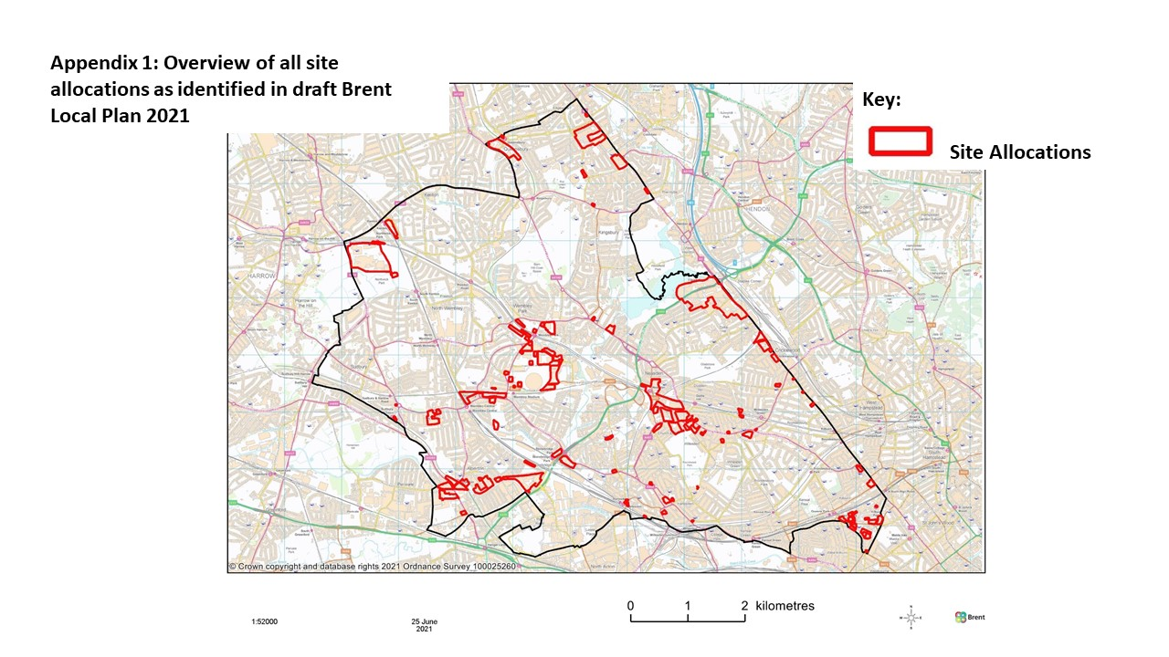

**Appendix 2 Waterfront Heights and Liberty Centre**

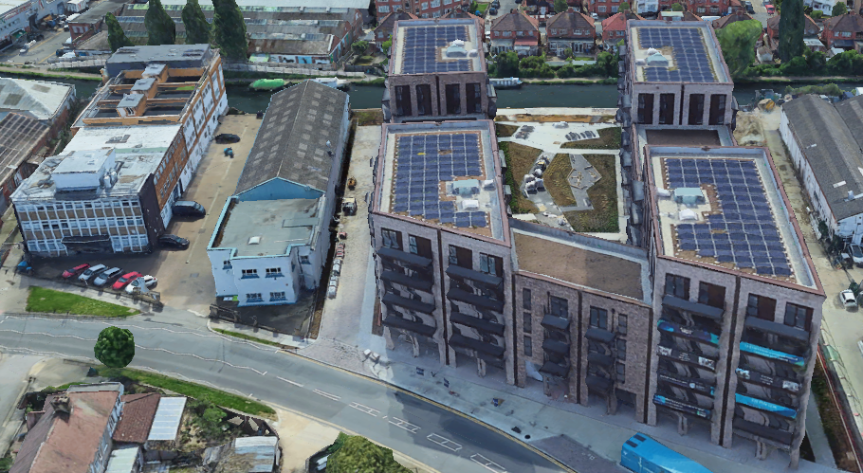

Ariel view from north along Mount Pleasant. Liberty Centre on the left of the picture incorporating prior approval dwellings with no private amenity space, Waterfront Heights on the right built with policy compliant quality housing and provision of ground employment space. Picture courtesy of Google Earth.

**Appendix 3 Waterfront Heights and Liberty Centre**

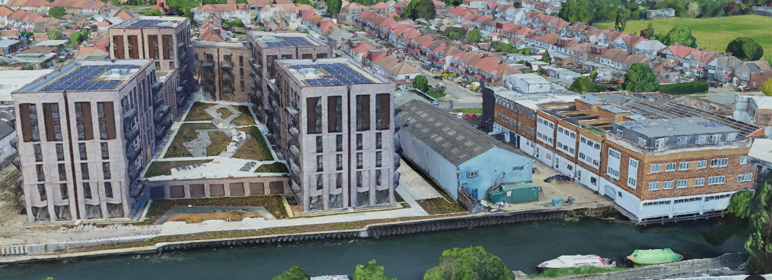

Ariel view from south along Grand Union Canal. Liberty Centre on the right of the picture, now compromising a planned contiguous canal path and Waterfront Heights on the left which includes space for a canal path. Picture courtesy of Google Earth.

**Appendix 4 Liberty Centre Public Footpath Boundary Treatment** 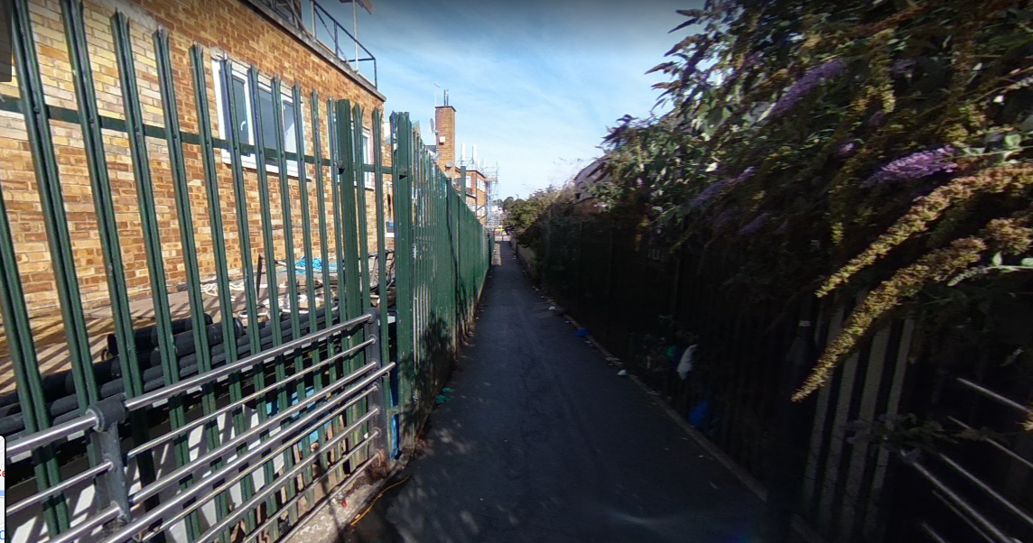

View along footpath from the canal to Mount Pleasant. Prior approval development of Liberty Centre on the right compromising planned improvement of footpath setting. Picture courtesy of Google Maps.